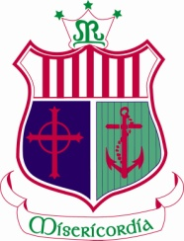
Weekly Events December 3rd -10th
Congratulations and well done to all those who participated in the following events
^{Mon 3rd} |  | Well done to Lauren O’Sullivan and Katie Sexton who received UL 40 Entrance Scholarships.
^{Tue 4th} | ^{Ms Mangan & Ms Harte} | Transition Year Students participated in Psychslam workshop in UCC. Aoibhinn Barrett, Amy Beechinor, Ella O’Donoghue, Hannah Sexton & Emma White  ^{3rd Year Retreat to Myross}
^{Wed 5th} | ^{Ms Harte}  ^{Irish Department} | Develop Me’ workshop for 4th year students  Cáith Amach é workshop for 6th year students
^{Thurs 6th} | ^{Ms Harte}  ^{Ms Brosnan} | Develop me workshop for 4th year students.  Well done to Orla Lowney who receive a UCC Quercus Entrance Award in UCC
^{Fri 7th} | ^{Ms Lonergan} | Well done to the students who participated in the cross Country event in Riverstick. The 1st & 2nd team finished in 2nd place.  Assessment Task for 3rd year students
^{Sat 8 th} | ^{Ms Walsh & Ms Brosnan} | Well done to the student who participate in the 10k as part of the Waterfront Marathon event.

